**Description of our Algorithm**: Quantum Approximate Optimization Algorithm

QAOA is a hybrid Quantum Algorithm designed to solve combinatorial optimization problems that are NP. An example is the Number Partition Problem:

**The Problem use to verify our results:**

we verified our algorithm on was an example of a Number Partition problem. ie you start with a list of numbers which you then try to separate into two lists such that, the difference between the sum of new list A and the sum of new list B is minimized. Our input list was [1,5,6] and we properly separated is ~ 45% of the time. (there were a lot of wrong possible outcomes and only 2 right ones so this is pretty good)

**The resource estimates obtained:**

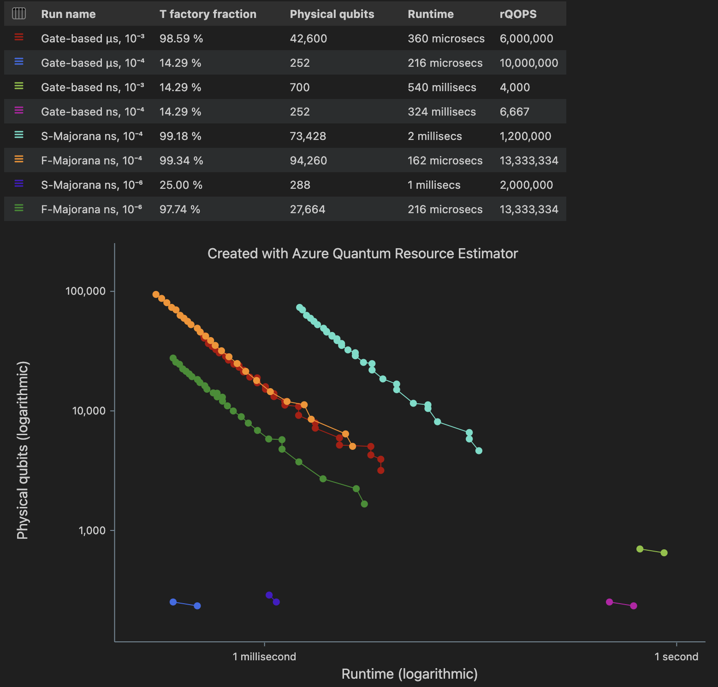

**Analysis of the estimates:**

Resource Estimator results, our recommendation to other attempting to solve a quadratic unconstrained binary optimization problem on Microsoft’s quantum software is that they use the ion based quantum computer with “surface_code” as quantum error correction scheme and an error rate budget of 9%.